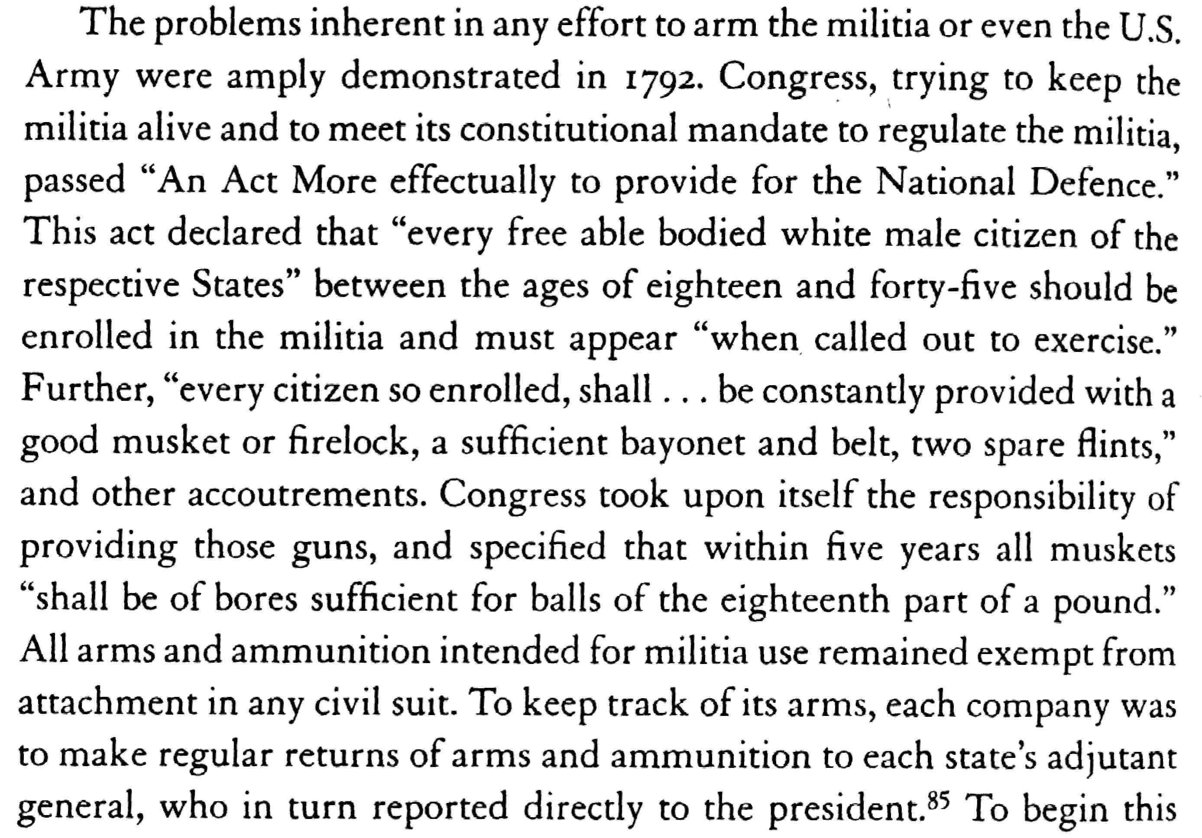

Bellesiles, p. 230 and citation

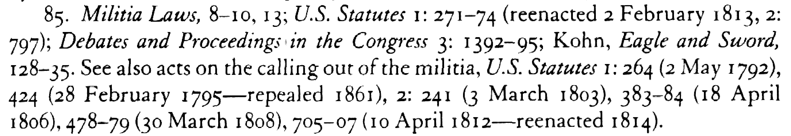

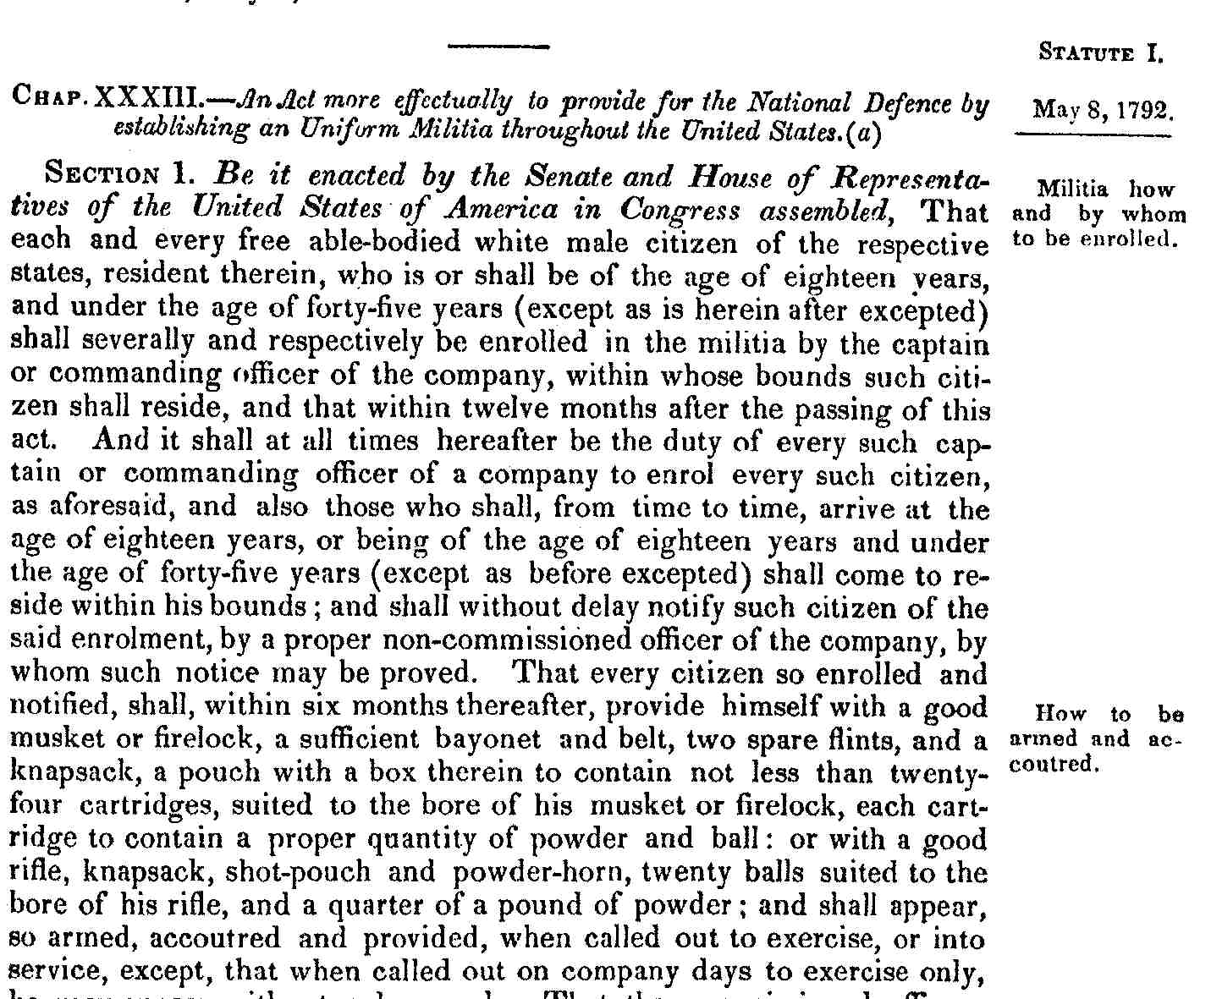

Debates and Proceedings in the Congress, 3:1392.

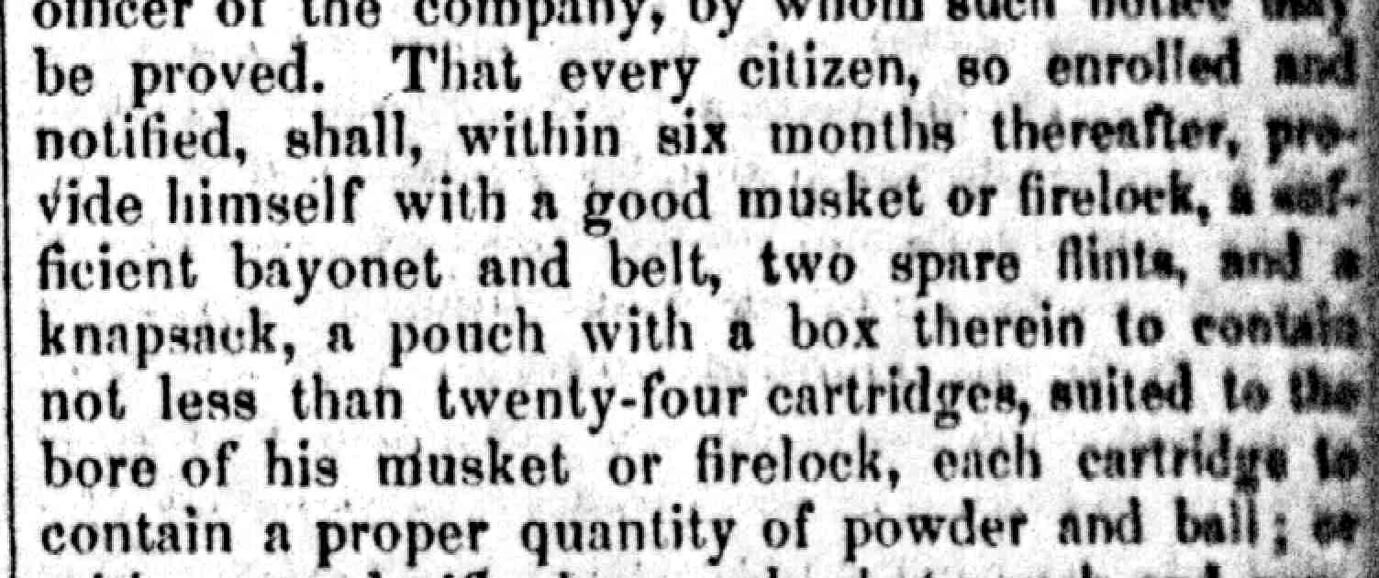
U.S. Statutes 1:271.

