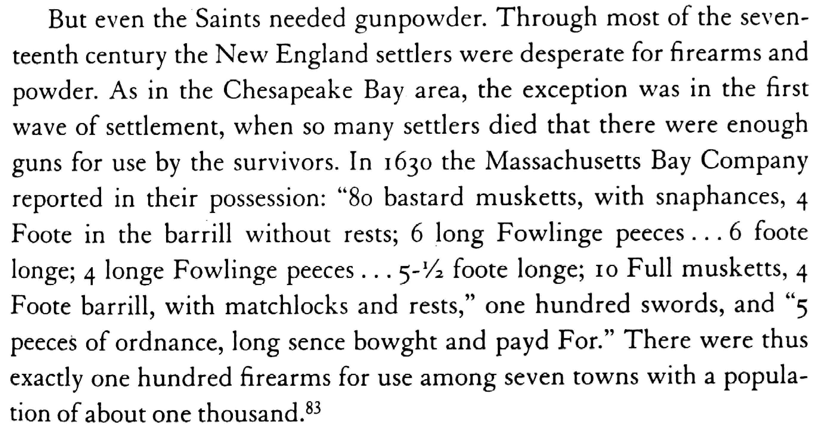

Bellesiles p. 63 and the citation

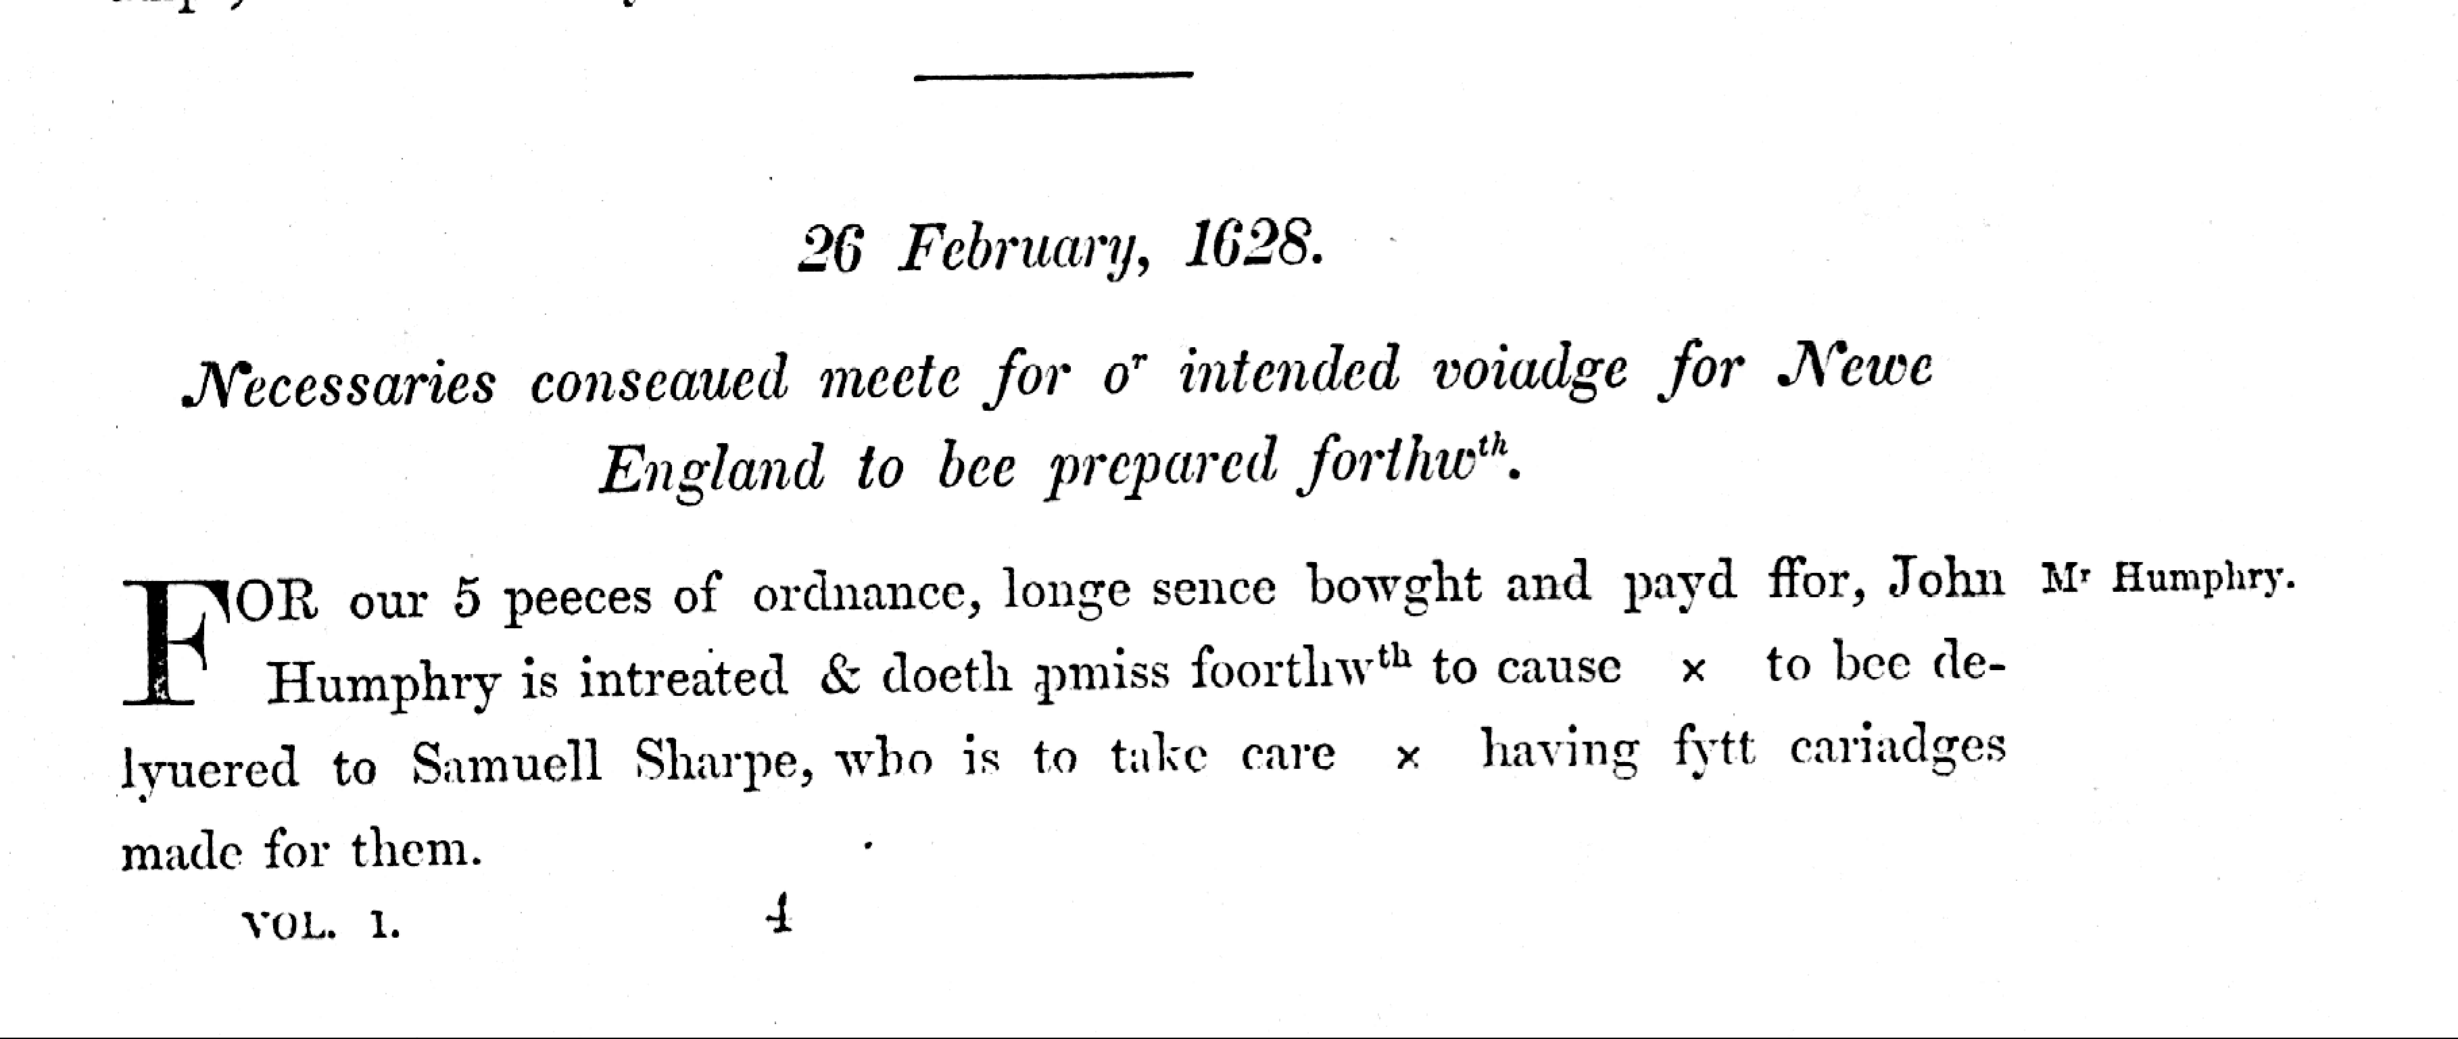
Shurtleff, ed., Records of Massachusetts Bay 1:25-26.

