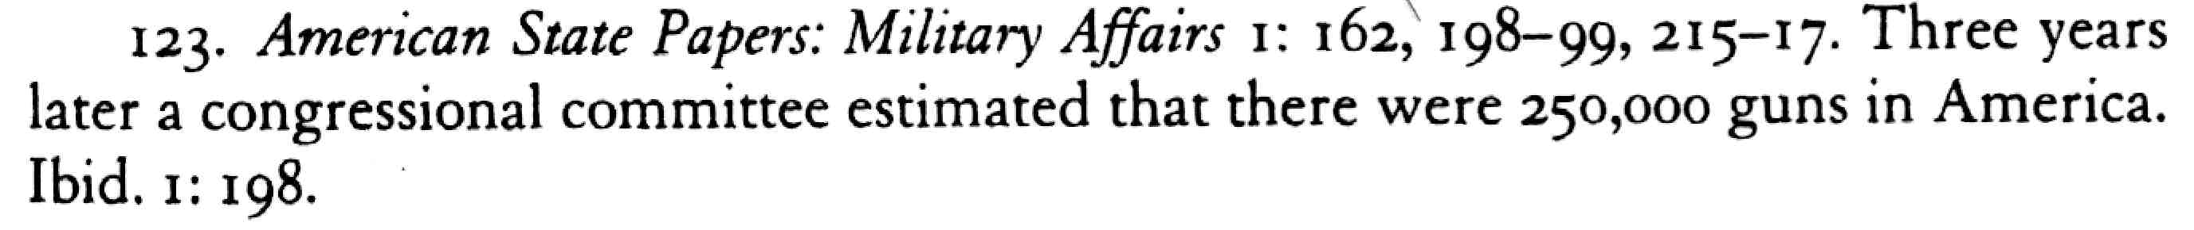

Bellesiles, p. 523

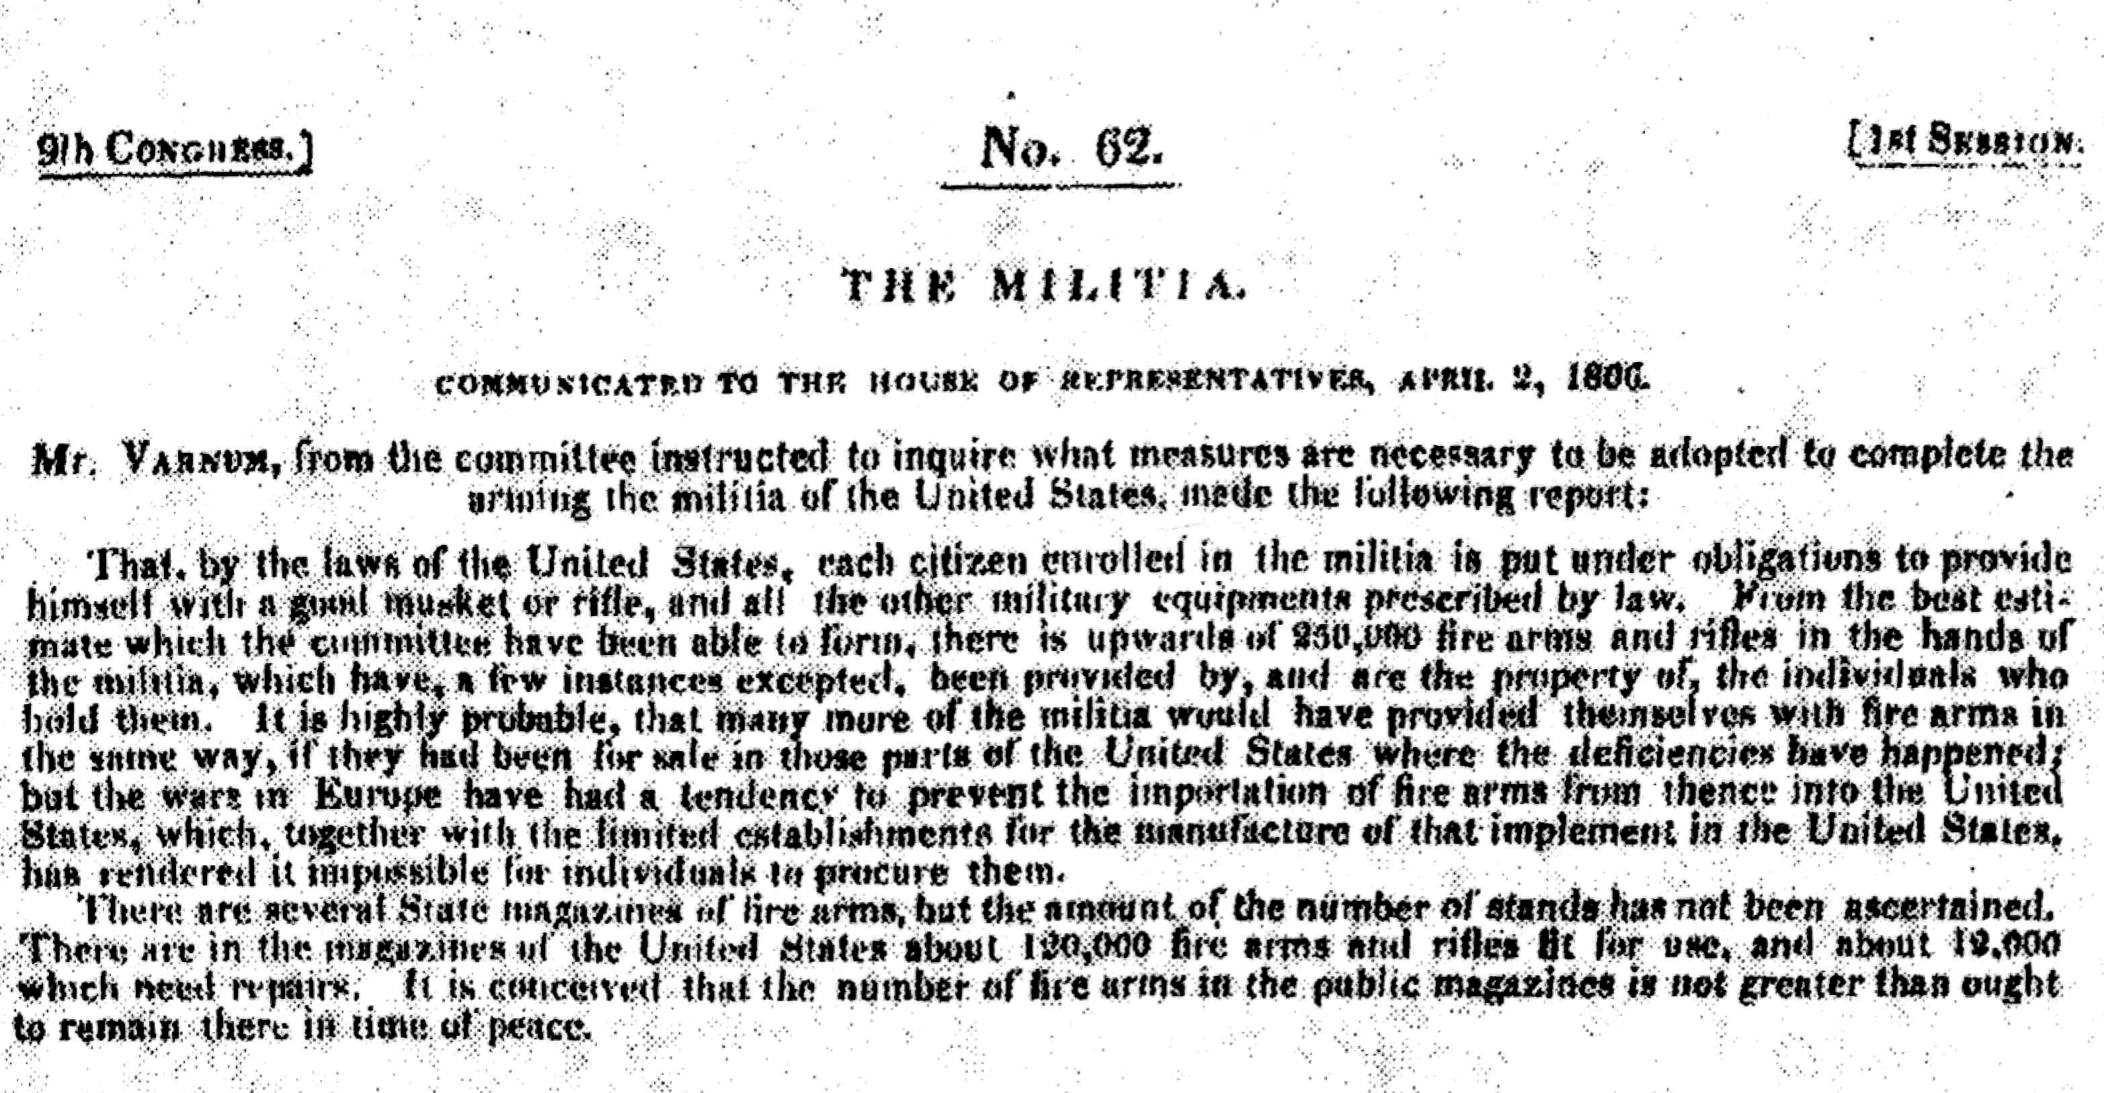
American State Papers: Military Affairs 1:198

