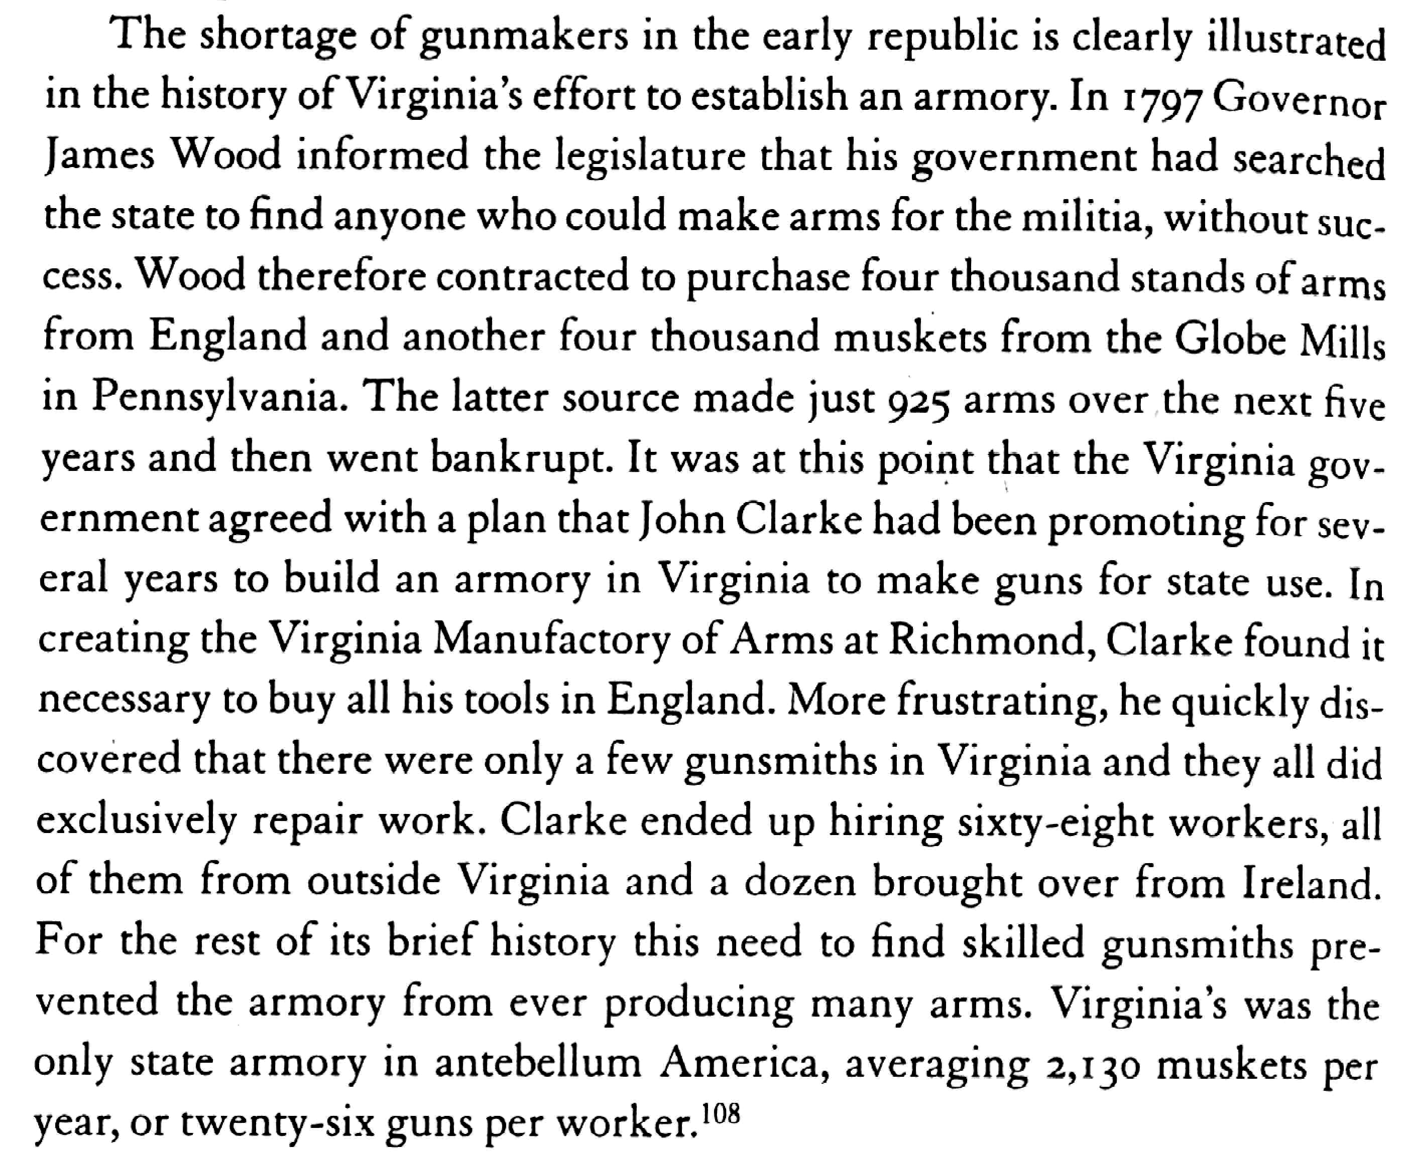

Bellesiles, p. 236 and citation

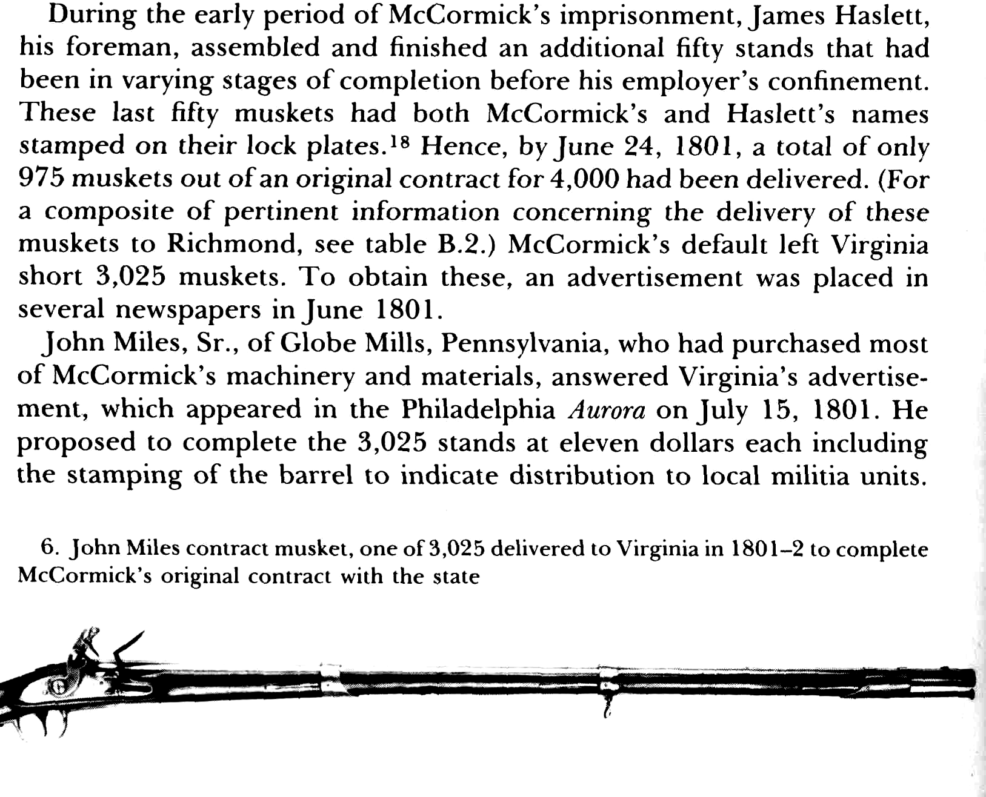

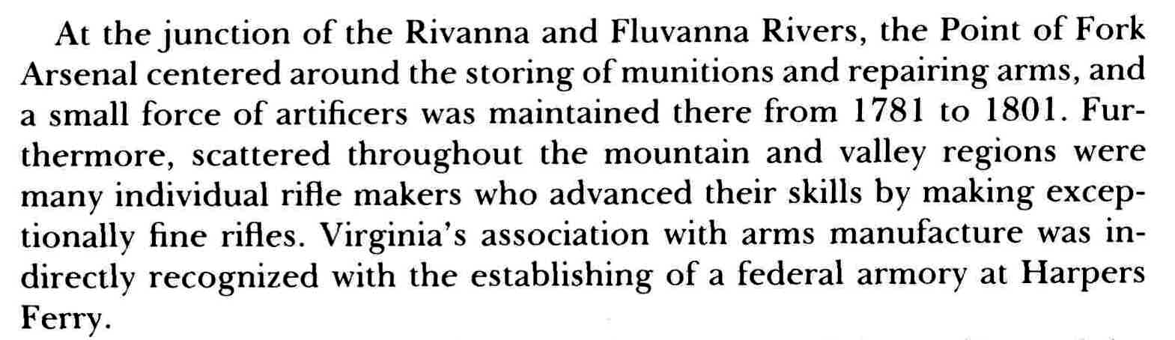
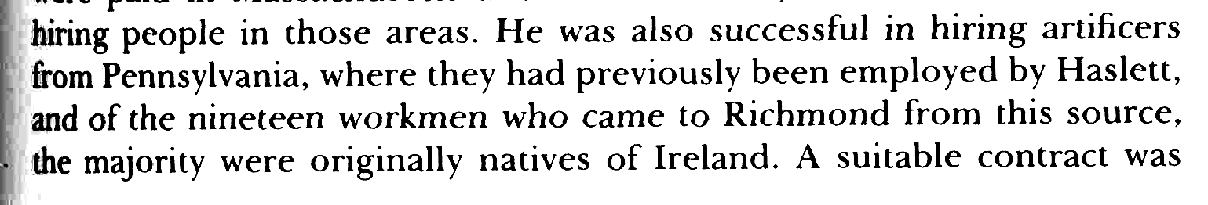
Giles Cromwell, The Virginia Manufactory of Arms,2, 6, 37

